Collaborative Project Contribution (322 words):

All sites accessed June 24

——

Some sentences adapted from <https://hiroshimaforpeace.com/en/reconstruction/page-2-1/>

Hiroshima used to be a small village with some small islands on the estuary of the Ota River. Various feudal lords fought for control over the village and its surrounding rice fields for centuries. The Meiji Restoration of 1868 brought radical change. The city of Hiroshima was recognized officially in 1889, as the prefectural capital. The city became a thriving economic and political hub. Soon, Hiroshima had a port, then a railroad, and the development of education and industry was soon to follow. By 1945, Hiroshima was recognized as an indispensable location, and troops were stationed in Western Japan and headquartered in Hiroshima.

——

Some sentences adapted from <https://www.nationalww2museum.org/war/articles/atomic-bomb-hiroshima>

The war in Europe ended in 1945, but Japan “refused to submit to the terms outlined in the Allies’ Potsdam Declaration”. American leaders decided to invade and conquer Japan, in response. The Japanese were poised for defense, and proved their fortitude on the battlefield in Okinawa. In light of American losses and dreary odds, the Truman administration met and decided to use the novel atomic bombs. Hiroshima was a choice target because of its military presence and weapons production. It defended the island of Kyushu and posed a threat to the invading allied forces.

On August 6, 1945, The American bomber, “Enola Gay”, carried a nuclear bomb called “Little Boy” to the skies above Hiroshima. The bomb detonated at 8:15 AM, at an altitude of 2000 feet. “The bomb vaporized people half a mile away” writes an article from the national world war 2 museum, “Bronze statues melted, roof tiles fused together, and the exposed skin of people miles away burned.” The death toll, beginning instantaneously at 80,000, rose to about 150,000 in the coming months.[(https://www.aasc.ucla.edu/cab/200708230009.html)](https://www.aasc.ucla.edu/cab/200708230009.html))

——

<https://translation2.j-server.com/LUCSHRSMC/ns/tl.cgi/https://www.city.hiroshima.lg.jp/site/atomicbomb-peace/276675.html?SLANG=ja&TLANG=en&XMODE=0&XPARAM=q,open_page_id,&XCHARSET=utf-8&XPORG=,,&XJSID=0>

The Mayor of Hiroshima protests the testing and use of atomic bombs internationally.

——

<https://www.city.hiroshima.lg.jp/site/english/158103.html>

The City of Hiroshima is still striving for peace. August 6 marks the Peace Memorial Ceremony, held in Hiroshima every year. On that day, the Mayor presents a Peace Declaration and the community gathers around the effort for nuclear disarmament and world peace.

After 75 years of proselytizing, those who survived the atomic bombings and still live today(Hibakusha, with an average age of 84) were able to witness the Treaty on the Prohibition of Nuclear Weapons which entered into force on 22 January 2021.

The Mayor of Hiroshima recognizes the value and intent of young people to “compel world leaders to turn away from nuclear deterrence.” “Nuclear weapons are the ultimate human violence.” “Experience has taught humanity that threatening others for self-defense benefits no one.”

——

Images

From <https://www.sabah.com.tr/galeri/dunya/obama-hirosimada-ozur-dilemedi/18>

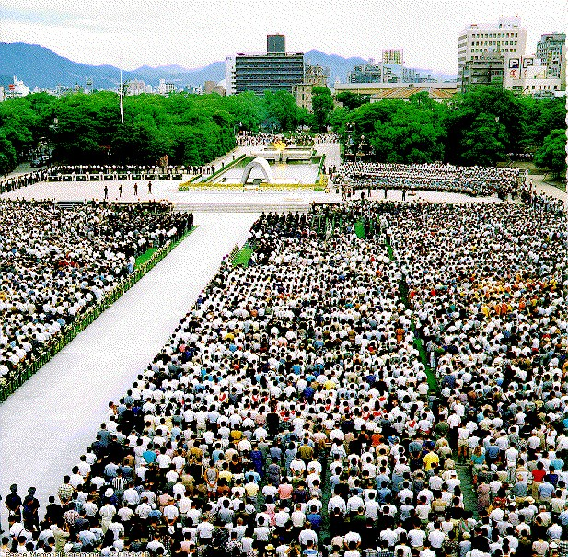

*60th Anniversary Hiroshima Peace Memorial Ceremony (2005)*

From <https://www.sabah.com.tr/galeri/dunya/obama-hirosimada-ozur-dilemedi/29>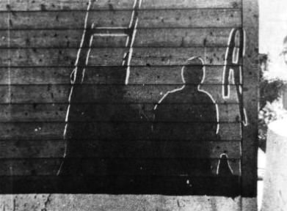

*The shadow of a man and his ladder scorched onto a wall*

From <https://www.airforcemag.com/app/uploads/2020/06/0620_Correll_005_Atomic_cloud_over_Hiroshima_seen_from_Matsuyama.jpg>

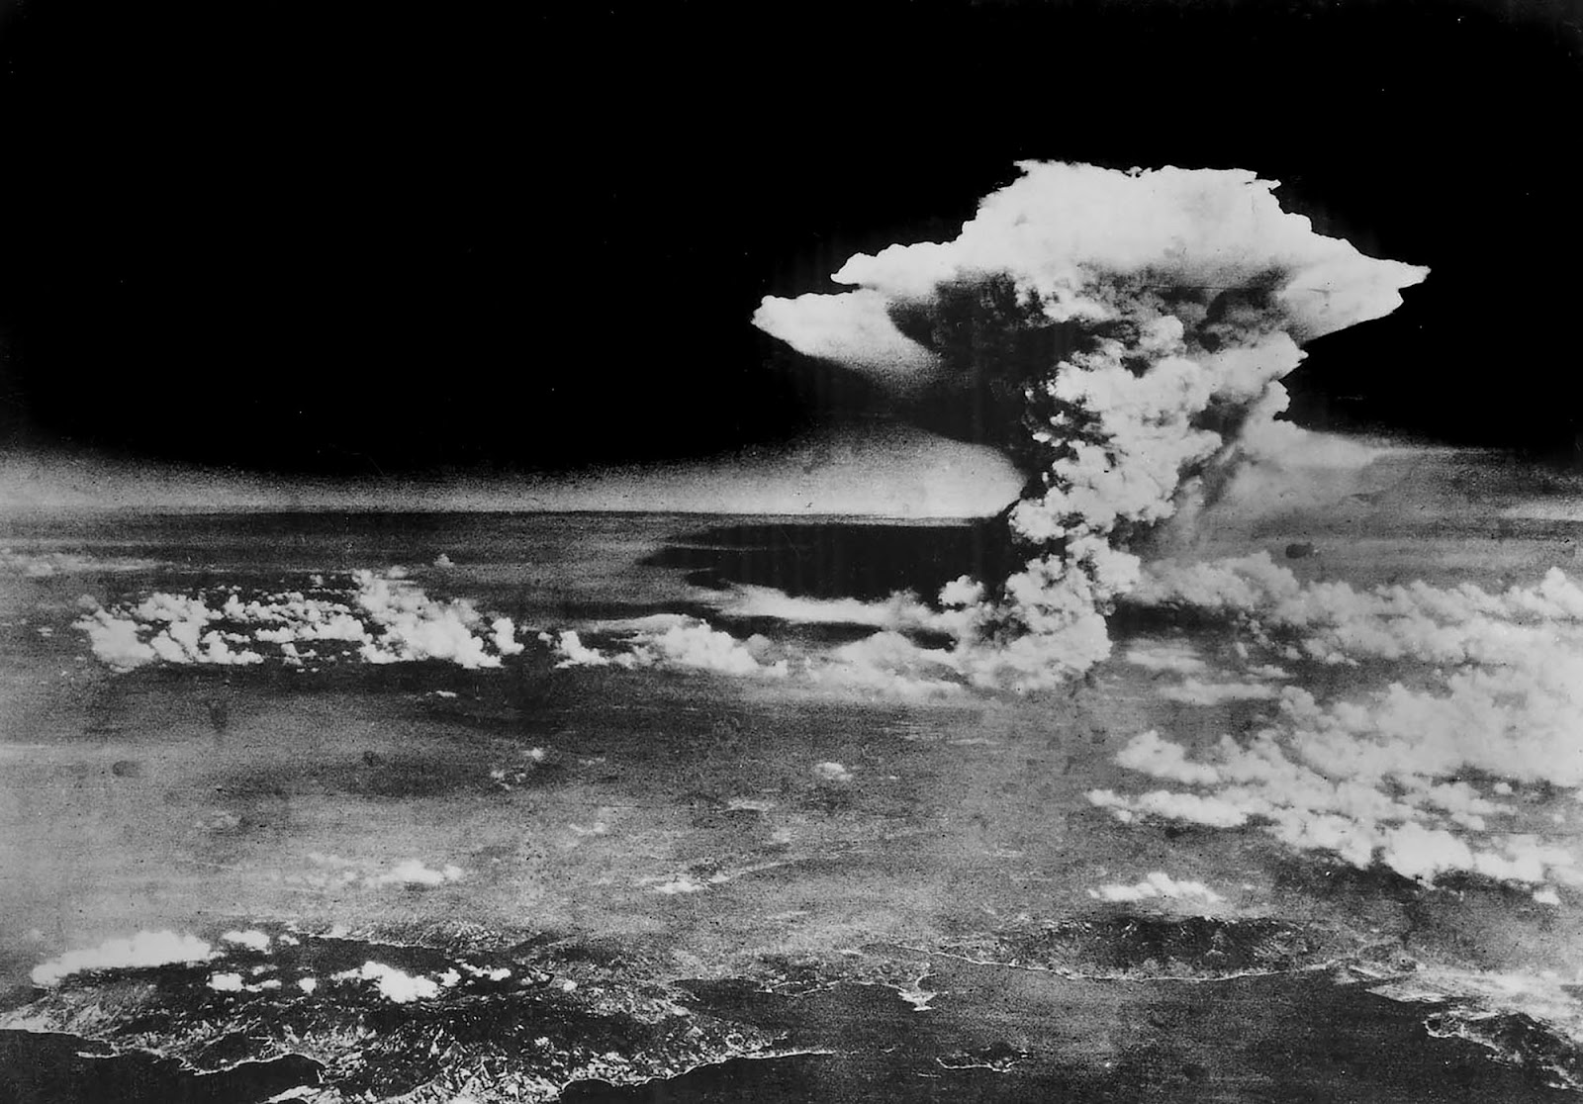

*The atomic blast over Hiroshima August 6, 1945, 8:15AM*

From <https://aaadablog.files.wordpress.com/2018/02/hiroshima_before_destruction-i.jpg>

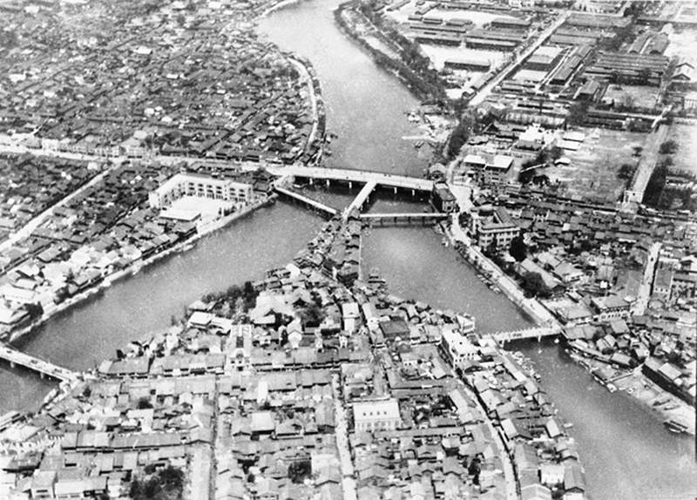

*Hiroshima prior to August 6, 1945*

From <https://weaponsparade.com/wp-content/uploads/nb-usa-Mk.1-LITTLE-BOY-Hiroshima-damage-3.jpg>

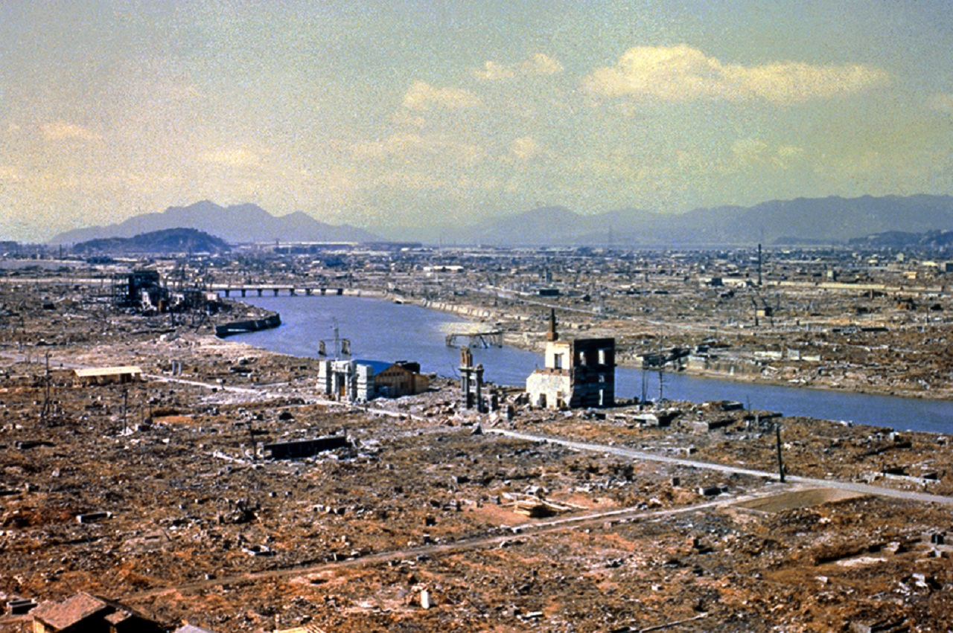

*The destruction of Hiroshima shortly after the Atomic Blast*

From <https://pbs.twimg.com/ext_tw_video_thumb/1291349868271874052/pu/img/wVRaX21oytEK4leQ.jpg>

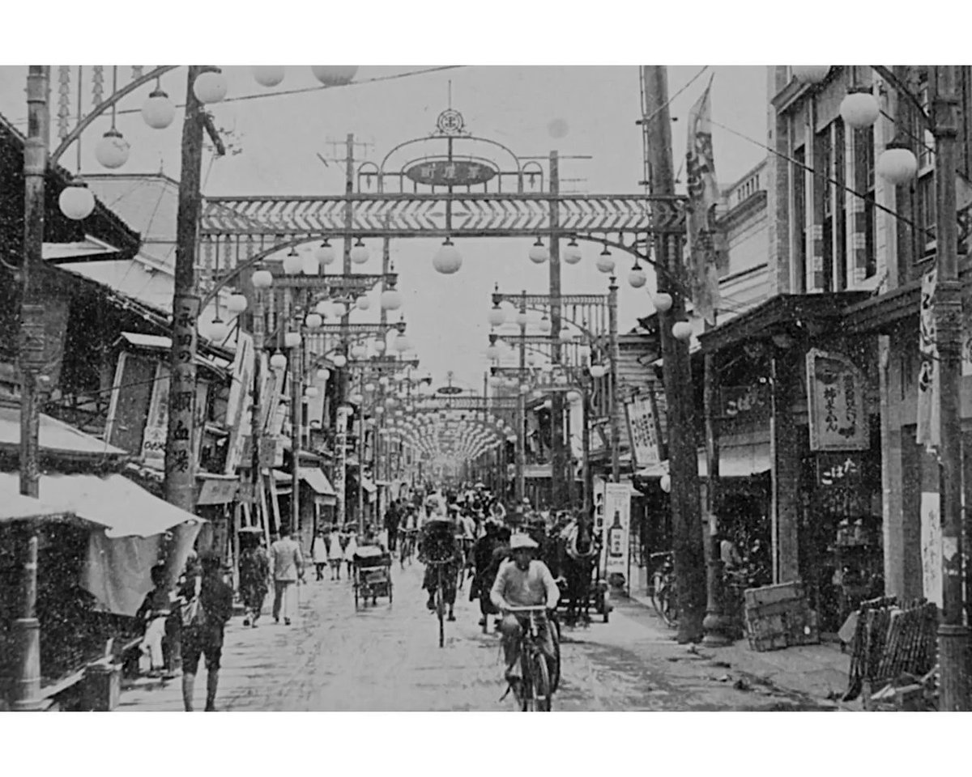

*Hiroshima prior to August 6, 1945*

From <https://portal.andina.pe/EDPfotografia3/Thumbnail/2020/08/05/000698912W.jpg>

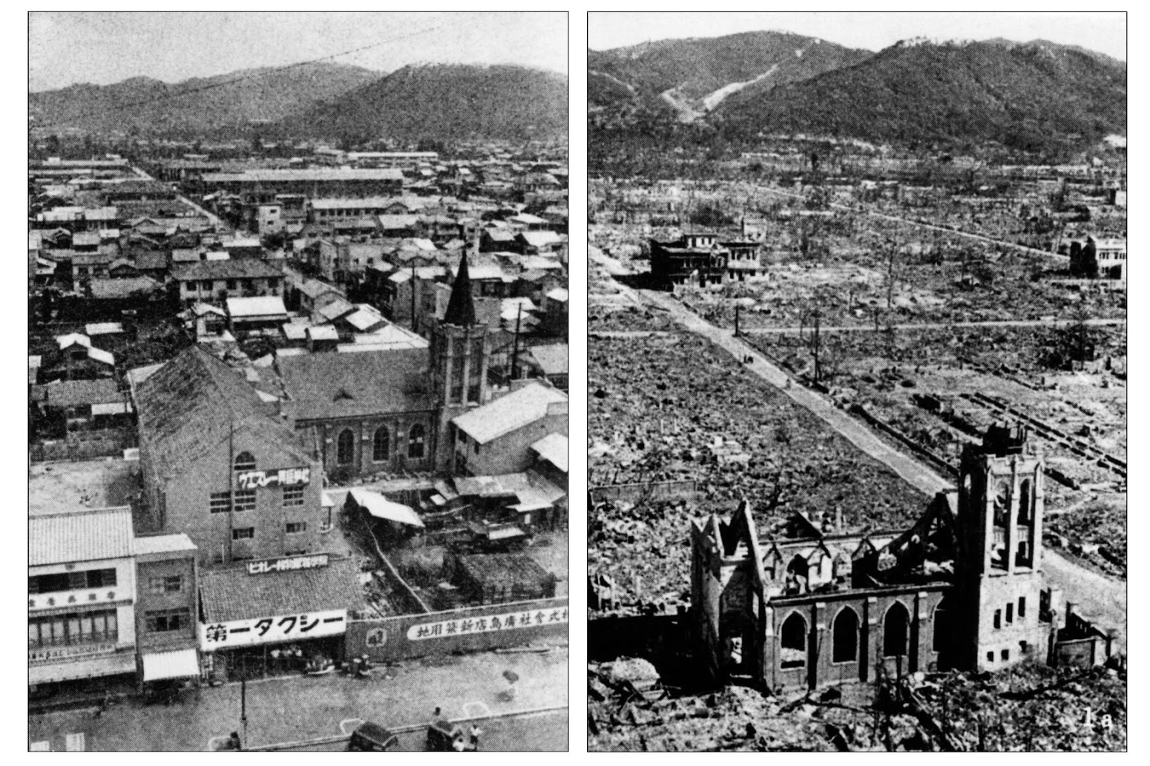

*Hiroshima before and after the Atomic Blast*

——

Additional resources:

Images, captions, and a blurb about the city:

<http://www.pcf.city.hiroshima.jp/virtual/VirtualMuseum_e/exhibit_e/exh1202_e/exh120201_e.html>

An American perspective on the bombs and the manhattan project:

<https://www.history.com/topics/world-war-ii/bombing-of-hiroshima-and-nagasaki>

Eye witness reports of the bombing:

<https://www.newyorker.com/magazine/1946/08/31/hiroshima>

Hiroshima City Website (English):

Archived version of Hiroshima City Website (English):

<https://web.archive.org/web/20150218093848/http://www.city.hiroshima.lg.jp/www/genre/0000000000000/1001000000021/index.html>

Articles on this front page maybe:

<https://hiroshimaforpeace.com/en/>

Treaty on the prohibition of nuclear weapons:

<https://www.un.org/disarmament/wmd/nuclear/tpnw/>